CURRICULUM VITAE

SYED NADEEM AHMED E-mail ID: - syednadeemahmed90@yahoo.com
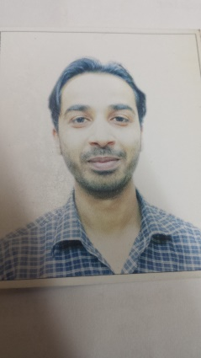

S/O:SYED SALEEM AHMED
H.NO: A/197, AREA 36/B
ZAMANABAD, LANDHI: 04
KARACHI, PAKISTAN
Mob: +92312-1101012

POST APPLIED FOR:- “Any Suitable Job”

CARRIER OBJECTIVE:-

To obtain a challenging and responsible position in an organization offering an opportunity to converge, System Support, Data Base Management, Office Administration and Project Support Services, develop and enhance my technical expertise for continuing growth and advancement in the Field.

QUALIFICATION:-
- Academic :-
- Matriculation (Science)
- Intermediate (Science)
- Bachelor of Science

- IT Skills and Knowledge:-

- Complete exposure in a computer working environment.
- All types of programmer Configuration in system.
- Maintains and installation.
- Typing 45 WPM
- CIT (Course in Information Technology).
- Lab Technician Course from Jinnah Postgraduate Medical Centre.

- Professional :-

EMPLOYMENT HISTORY:

- Working with
Indus Lube Oils Company (Pvt) Ltd As a “Assistant Accountant”.
From 19th Mar, 2019 To Till date.

- Working With
The Southend Club (Pvt) Ltd. DHA ( Cricket Stadium ) as a “ Administrative Assistant” From 19th Oct 2017 To 15th Mar 2019.

- El-Seif Engineering & Contracting Company:
Administrative Assistant in Thumamah Camp Riyadh. Project-316
FROM 29th April 2011 To 11th Jul 2017 In KINGDOM OFSAUDI ARABIA.

- Worked with DESIGN INTERNATIONAL as a “ Administrative Assistant ”
FROM 2010-2011
Korangi Industrial Area, Karachi Pakistan.

- Home Tuitions as a Tutor FROM 2006-2011

- DUTIES :-

- Arranging cricket matches and resolving problems.
- Resolving routine administrative problems.
- Resolving club facilities complain.
- Explain and arranging new club membership.
- Issuing membership cards renewal/lost/Car Parking Sticker.
- Checking emails as well as voice mails and ensuring a time responses to all inquiries.
- Preparing routine documents for senior managers.
- Receiving and distributing mail.
- Taking phone message.
- Photo coping various documents.
- Preparing agenda and meeting material.
- Ordering office stationary.
- Organizing refreshments such as tea and biscuits for senior managers and visitors.

Personal Details:

- Name :Syed Nadeem Ahmed
- Father’s Name :Syed Saleem Ahmed
- Date of Birth :28 February,1985
- Religion : Islam
- Gender :Male
- Marital Status :Married
- Nationality :Pakistani
- Language Known : Arabic, English, Urdu.

Passport Details:

- Passport Number :BN5176622
- Date of Issue :01/12/2012
- Date of Expire :29/11/2022
- Place of Issue :Karachi
- Place of Birth :Karachi(PAKISTAN)

DECLARATION:

I hereby declare that the information above are given is true and correct to the best of my Knowledge and belief. Here I shown all my qualification and experience, hope you will consider my C.V and give me the chance to serve your esteemed organization.

SYED NADEEM AHMED

