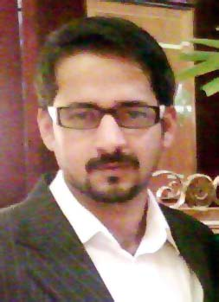
s
Syed Mohammad Taha
Address: 16/19, C Area Liaquatabad Karachi, Pakistan
E-mail: tahagr8@hotmail.com
Mobile #: 0345-4512167, 0333-4512166

OBJECTIVE

Seeking for a growth and challenging position with great emphasis on computerized environment with result oriented organization and intensive to utilize my experience and skills thus culminating into a rewarding career.

EXPERIENCE

Sales Executive at MDK Japan (11 Nov 2017 – 22 June 2018)
- Outbound calls to dealers for business to business deal.
- Contacting them through digital media for business to business deal and resolutions of issue.
- Collecting dealer’s data.

Shift Supervisor at Daraz.pk Ware House (11 Nov 2016-18 July 2017)

- Managing Inventory in Warehouse of Daraz.pk
- Deep overview of Inbound and Outbound Logistics
- Looking after Customers Purchase Orders (PO’s)
- Managing Vendors Issues.
- Managed Pickups/Returns and Rejects of Customers and Vendors.
- Managing 3PL shipments.
- Looking after Dispatch
- Making SOP’s for Ware House
- End user of OMS,DM and Zendesk.

Customer Service Representative in K-Electric (17 March 2014 –20 Nov 2016)
- Inbound calls of consumers and solve issue of consumers
- End user of S.A.P (CRM)
- End user of calling software’s: Genesis, Siemens calling software.
- Out bond calls to consumers
- Worked on consumer data collection and billing issues.

ACADEMIC QUALIFICATION

2012-2014 MPA (Up Held) from University Of Karachi
2010 B.sc from University Of Karachi
2007 Intermediate from Jinnah Govt. College For Men Nazimabad Karachi
2002-2003 Matriculation from Board of Secondary Education Karachi

COMPUTER SKILLS

Well versed with the following software / Operating System.
➢ Microsoft Office
➢ Microsoft Windows, Excel
➢ Command over Internet & e-mail.
➢ End user of S.A.P (crm)

TRAININGS/WORKSHOPS

Well versed with the following software / Operating System.
➢ SEERAT UN NABI (S.A.W.W) CONFERENCE
➢ LEADERSHIP CONFERENCE
➢ D-MAC.

PERSONAL INFORMATION

Date of Birth: April 05 1988
N.I.C. No: 42101-5706558-3
Marital Status: Married
Languages: English / Urdu

REFERENCES

Shall be provided, when asked for.

